Lauren Testimonial

Before we got pregnant, we were certain that we couldn’t handle a special needs child, and that if the time came, we might choose termination rather than face a lifetime of challenges. We had an ultrasound at 8 weeks and saw the little heart beat on the screen, and were completely awed that we had created new life. A few weeks later, we got the results of the triple screen blood test right and it showed an elevated risk for Down Syndrome – 1 out of 133. We decided that was a really small number, and we didn’t want to live our lives reacting to risks. We’d never get behind the wheel of a car if that were true! We opted against an amnio because of the risk to the baby, and because by that point, we couldn’t possibly imagine termination for something that wasn’t life threatening to me or to her.
When Lauren was born, the pediatrician thought she should be tested, because she had a few markers, but not all of them. She had slanted eyes, but not lowered ears or a simian crease in her palm or sandal toe. She scored an 8/9 on the apgar, and we were pleased that on the second night she learned how to nurse. We took her home and were so happy with our new baby.
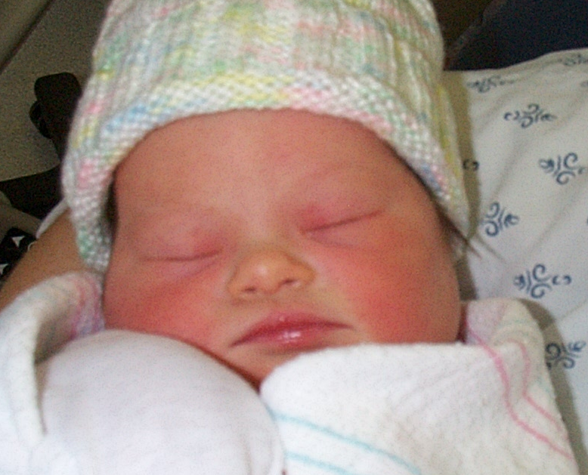
A week later we learned that she tested positive for Trisomy 21, and we were pretty devastated. I remember thinking that I wanted to have the child that would be reading by kindergarten; not to have the child that will teach other kids how to be patient and accepting. With great support from both our families, we made it through the first few days, which were the hardest. We alternated between which one of us was the stronger and would shore up the other one.
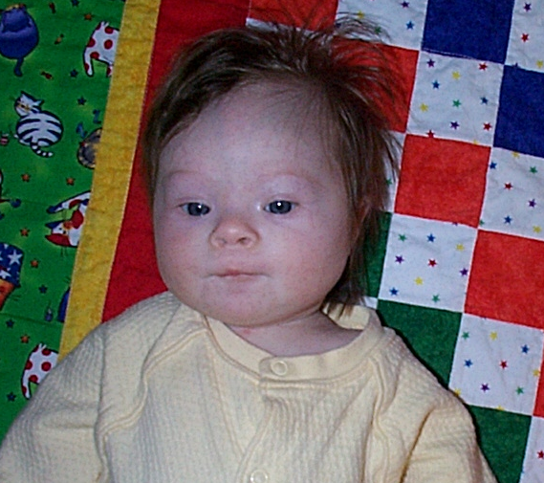
We immediately connected with the early intervention program. If it could make a difference in Lauren’s life, we wanted to get started right away. We read a lot of information, both in books and on the web. We pushed pretty hard to have an evaluation quickly, the IFSP quickly, to start therapy right away. Lauren had some early successes in that she was able to nurse, and did not have any heart or bowel problems.
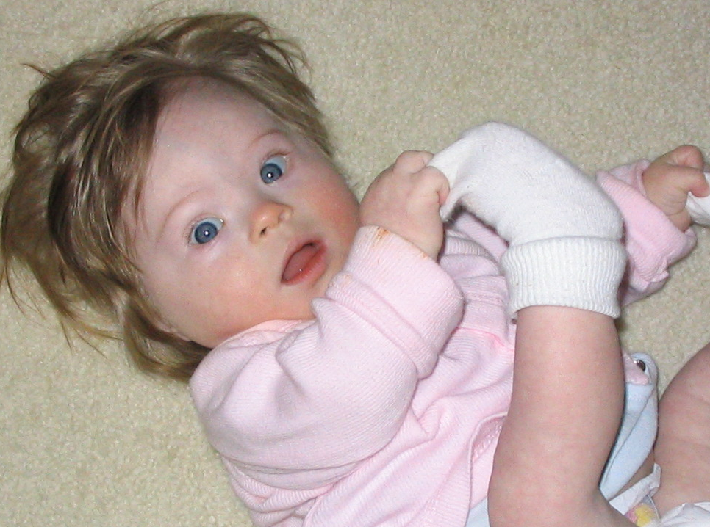
Since that time, life has been mostly ‘up’ rather than ‘down’. Lauren started smiling and never stopped. She worked very hard to be able to sit up, and loves being sung to. She received OT and PT once a week each for the first 6 months, and now she receives therapy twice a week each. We’ve only had one scare; she contracted bronchiolitis in January and was in the hospital for 12 days. She needed to be in an oxygen tent 24 hours a day to start, but as she got better, she weaned down to needing it only while sleeping, to needing it only at night. Since then, she’s had a lot of colds, but nothing too serious. She is now 11 months old, and doing many things that average 11 months old do. Tupperware and plastic bags are her favorite toys, it doesn’t matter what kind of electronic gadget we bought. She can drink out of a straw, likes yogurt and loves to make noise.
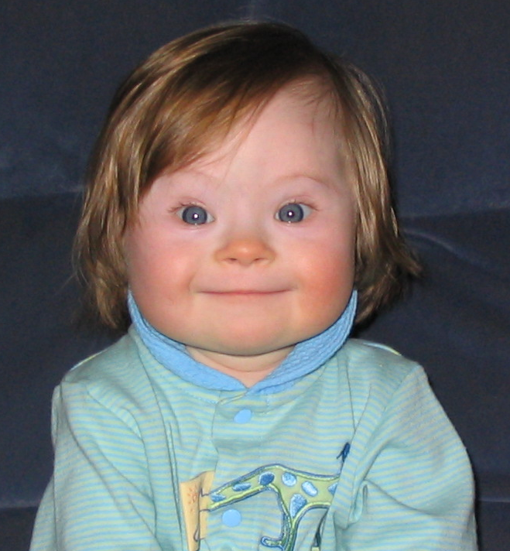
I can still feel twinges of jealousy when I see babies that are 14 months old who know 6 signs, and know that the cow says, “moo!” I know Lauren won’t be doing those things when she’s 14 months. But she gives us the biggest hugs and sloppiest kisses, and I know she loves us with her whole heart and always will. She is a really great little girl who works hard to grow and develop, but doesn’t have to work hard to endear herself to everyone she meets. I look forward to seeing her grow up, because I know she will work hard and achieve a lot of success. Just look at how far she has come in her short life so far!
